705.641.81: Natural Language Processing Self-Supervised Models
Homework 3: Building Your Neural Network!
For homework deadline and collaboration policy, please see our Canvas page.
Name: Albert Rojas De Jesus
Collaborators, if any: ____________________________________________________
Sources used for your homework, if any: _______________________________________
- (Jacobian structure) Magnus, J. R., & Neudecker, H. Matrix Differential Calculus with Applications in Statistics and Econometrics. 1999
- (Linear Algebra, Gradients, Jacobians) Petersen, K. B., & Pedersen, M. S. The Matrix Cookbook. Technical University of Denmark. 2012
- Goodfellow, Bengio & Courville Deep Learning, Chapter 6 (2016) https://www.deeplearningbook.org
  - Sigmoid, Tanh, ReLU and their derivatives
- Zhang, A. et al., (2024). Dive into Deep Learning, Cambridge University Press. https://d2l.ai/index.htm

This assignment is focusing on understanding the fundamental properties of neural networks and their training.
Homework goals: After completing this homework, you should be comfortable with:
- thinking about neural networks
- key implementation details of NNs, particularly in PyTorch,
- explaining and deriving Backpropagation,
- debugging your neural network in case it faces any failures.

Concepts, intuitions and big picture
- Suppose you have built a neural network. You decide to initialize the weights and biases to be zero. Which of the following statements are True? (Check all that apply)
$✔️$ Each neuron in the first hidden layer will perform the same computation. So even after multiple iterations of gradient descent each neuron will be computing the same thing as other neurons in the same layer.
$▫$ Each neuron in the first hidden layer will perform the same computation in the first iteration. But after one iteration of gradient descent they will learn to compute different things because we have “broken symmetry”.
$▫$ Each neuron in the first hidden layer will compute the same thing, but neurons in different layers will compute different things, thus we have accomplished “symmetry breaking” as described in lecture.
$▫$ The first hidden layer’s neurons will perform different computations from each other even in the first iteration; their parameters will thus keep evolving in their own way.
- Vectorization allows you to compute forward propagation in an $L$-layer neural network without an explicit for-loop (or any other explicit iterative loop) over the layers $l=1,2,×,L$. True/False?
$▫$ True
$✔️$ False
- The tanh activation usually works better than sigmoid activation function for hidden units because the mean of its output is closer to zero, and so it centers the data better for the next layer. True/False?
$✔️$ True
$▫$ False
- Which of the following techniques does NOT prevent a model from overfitting?
$▫$ Data augmentation $▫$ Dropout $▫$ Early stopping $✔️$ None of the above
- Why should dropout be applied during training? Why should dropout NOT be applied during evaluation?
To avoid overfitting is the reason why the dropout strategy is only applied during training (i.e. memorizing the training data). At each training step, dropout randomly removes a neuron from the network to encourage redundancy by forcing the network to use other nodes. In addition, dropout is not applied during evaluation or testing time as we are interested in the reliable deterministic predictions that are obtained by using all available representations.
- Explain why initializing the parameters of a neural net with a constant is a bad idea.
Setting all weights to zero, or to any other constant, is not efficient as it does not break symmetry between neurons in the same layer, all neurons with the same weight will produce the same output during feed forward and receive the same gradient during backpropagation, this will remain equivalent throughout the entire training process. This means that the network will not learn a variety of features and groups of neurons will resemble only one neuron doing the same thing multiple times. Random initialization avoids this situation.

- You design a fully connected neural network architecture where all activations are sigmoids. You initialize the weights with large positive numbers. Is this a good idea? Explain your answer.
No, this is not a good idea. If we initialize the weights to large positive numbers, then when we start the network, we will be moving the inputs up the sigmoids. The sigmoid floods to one for large positive inputs. Making the neurons to always output values close to one, which causes the derivative of the sigmoid to be close to zero. if this happens, the weight updates during backpropagation will become extremely small, which will lead to extremely slow training or the training stopping prematurely.
- Explain what is the importance of “residual connections”.
Residual connections make training large with numerous hidden layers also called deep neural networks easier. This is done by allowing gradients and information to skip or transport information over many layers. Instead of requiring each learnable layer to change the input from the former layer into a different representation, residual connections need only learn the residual between the input and the output of the subsequent layer. This helps to avoid the problems stated by the previous question such as vanishing gradients, which in turn makes optimization easier, this allows very deep networks to converge faster.
- What is cached (“memoized”) in the implementation of forward propagation and backward propagation?
$✔️$ Variables computed during forward propagation are cached and passed on to the corresponding backward propagation step to compute derivatives.
$▫$ Caching is used to keep track of the hyperparameters that we are searching over, to speed up computation.
$▫$ Caching is used to pass variables computed during backward propagation to the corresponding forward propagation step. It contains useful values for forward propagation to compute activations.
- Which of the following statements is true?
$✔️$ The deeper layers of a neural network are typically computing more complex features of the input than the earlier layers.
$▫$ The earlier layers of a neural network are typically computing more complex features of the input than the deeper layers.

Revisiting Jacobians
Recall that Jacobians are generalizations of multi-variate derivatives and are extremely useful in denoting the gradient computations in computation graph and Backpropagation. A potentially confusing aspect of using Jacobains is their dimensions and so, here we’re going focus on understanding Jacobian dimensions.

Recap:
Let’s first recap the formal definition of Jacobian. Suppose $f:R^{n}→R^{m}$ is a function takes a point $x∈R^{n}$ as input and produces the vector $f\left(x\right)∈R^{m}$ as output. Then the Jacobian matrix of $f$ is defined to be an $m×n$ matrix, denoted by $J_{f}\left(x\right)$, whose $\left(i,j\right)$th entry is $J_{ij}=\frac{∂f_{i}}{∂x_{j}}$, or:
$$J=\left[\begin{matrix}\frac{∂f}{∂x_{1}} & ⋯ & \frac{∂f}{∂x_{n}}\end{matrix}\right]=\left[\begin{matrix}∇^{⊤}f_{1} \\ ⋮ \\ ∇^{⊤}f_{m}\end{matrix}\right]=\left[\begin{matrix}\frac{∂f_{1}}{∂x_{1}} & ⋯ & \frac{∂f_{1}}{∂x_{n}} \\ ⋮ & ⋱ & ⋮ \\ \frac{∂f_{m}}{∂x_{1}} & ⋯ & \frac{∂f_{m}}{∂x_{n}}\end{matrix}\right]$$

Examples:
The shape of a Jacobian is an important notion to note. A Jacobian can be a vector, a matrix, or a tensor of arbitrary ranks. Consider the following special cases:
- If $f$ is a scalar and $\text{w}$ is a $d×1$ column vector, the Jacobian of $f$ with respect to w is a row vector with $1×d$ dimensions.
- If $\text{y}$ is a $n×1$ column vector and $\text{z}$ is a $d×1$ column vector, the Jacobian of $z$ with respect to $y$, or ${\text{J}}_{\text{z}}\left(\text{y}\right)$ is a $d×n$ matrix.
- Suppose $\text{A}∈R^{m×n}$ and $B∈R^{l×p×q}$. Then the Jacobian ${\text{J}}_{\text{A}}\left(\text{B}\right)$ is a tensor of shape $\left(m×n\right)×\left(l×p×q\right)$. More broadly, the shape of the Jacobian is determined as (shape of the output)$×$(shape of the input).

Problem setup:
Suppose we have:
- $X$, an $n×d$ matrix, $x_{i}∈R^{d×1}$ correspond to the rows of $X={\left[x_{1},…,x_{n}\right]}^{⊤}$
- $Y$, a $n×k$ matrix
- $W$, a $k×d$ matrix and $w$, a $d×1$ vector
For the following items, compute (1) the shape of each Jacobian, and (2) an expression for each Jacobian:
- $f\left(w\right)=c$ (constant)
- $shape=1×d$
- Expression :
$$\frac{∂f}{∂w_{j}}=0$$
$$J_{f}\left(w\right)=\frac{∂f}{∂w}=\left[0 0…0\right]$$
- Expression = $J_{f}\left(w\right)=0×d$
- $f\left(w\right)=∥w∥^{2}$ (squared L2-norm)
  - Shape =$1×d$
  - Expression:
$$\frac{∂f}{∂w_{i}}Σ_{j=1}^{d} w_{j}^{2}=2w$$
$$f\left(w\right)=2w$$
$$J_{j}\left(w\right)=2w^{T}$$
- $f\left(w\right)=w^{⊤}x_{i}$ (vector dot product)
  - $shape=1×d$
  - Expression =
$$\frac{∂}{∂w_{j}}Σ_{k=1}^{d}w_{k}x_{ik}=x_{ij}$$
$$f\left(w\right)=x_{i}$$
$$J_{f}\left(w\right)=x_{i}^{T}$$
- $f\left(w\right)=Xw$ (matrix-vector product)
  - $shape=n×d$
  - $expression:$
$$f_{i}\left(w\right)=Σ_{j=1}^{d}X_{ij}w_{j}$$
$$\frac{∂f_{i}}{∂w_{j}}=X_{ij}$$
$$J_{f}\left(w\right)=X$$
- $f\left(w\right)=w$ (vector identity function)
  - $shape=d×d$
  - Expression =
$$f_{i}\left(w\right)=w_{i}$$
$$\frac{∂f_{i}}{∂w_{j}}=\left\{\begin{aligned}1, &if i=j \\ 0, &if i≠j\end{aligned}\right.$$
$$J_{f}\left(w\right)=I_{d}$$
- $f\left(w\right)=w^{2}$ (element-wise power)
  - $shape=d×d$
  - $expression=$

$$\frac{∂f_{i}}{∂w_{j}}=\frac{∂(w_{i}^{2})}{∂w_{j}}=\left\{\begin{aligned}2w_{i}, &if i=j \\ 0, &if i≠j\end{aligned}\right.$$
$$J_{f}\left(w\right)=diag\left(2w_{1},2w_{2}, …2w_{d}\right)$$
$$J_{f}\left(w\right)=2 diag(w)$$

- Extra Credit: $f\left(W\right)=XW^{⊤}$ (matrix multiplication)

Activations Per Layer, Keeps Linearity Away!
Based on the content we saw at the class lectures, answer the following:
- Why are activation functions used in neural networks?
The purpose of activation functions is to introduce nonlinearity into the model. Without activation functions, each layer would only be a linear transformation, and the composition of multiple linear transformations would be a linear transformation. This would greatly limit a network's ability to capture complicated features. Non-linear activation functions, such as ReLU, or their variants sigmoid and tanh are used to learn non-linear functions. This helps non linear data in the neural network. This is used to discover complex patterns which can be found in image classification.
- Write down the formula for three common action functions (sigmoid, ReLU, Tanh) and their derivatives (assume scalar input/output). Plot these activation functions and their derivatives on $\left(-∞,+∞\right)$.
  - Sigmoid
$$σ\left(x\right)=\frac{1}{1+e^{-x}}$$
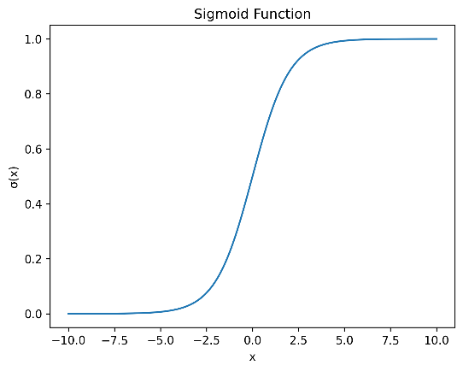
$$σ^{'}\left(x\right)=σ\left(x\right)\left(1-σ\left(x\right)\right)$$
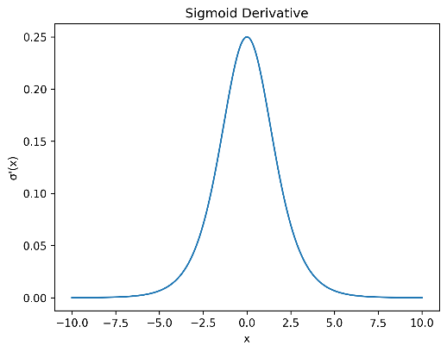
ReLU:
$$ReLu\left(x\right)=\max\left(0,x\right)$$
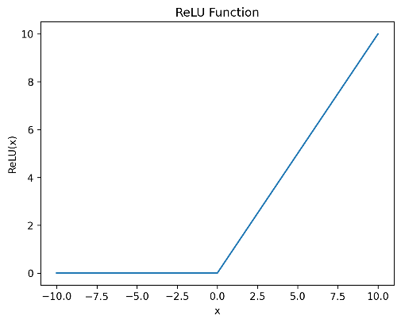
$$RelU^{'}\left(x\right)=\left\{\begin{aligned}1 x>0 \\ 0 x<0\end{aligned}\right.$$
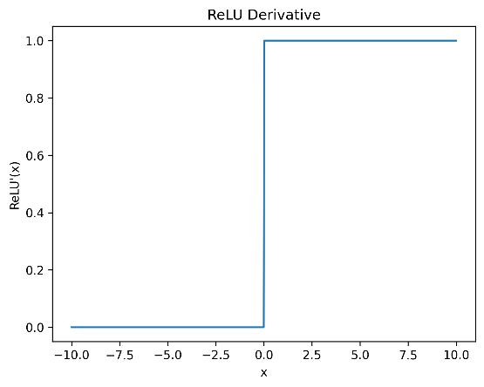
Tanh:
$$tahn\left(x\right)={(e}^{x}-e^{-x})/(e^{x}+e^{-x})$$
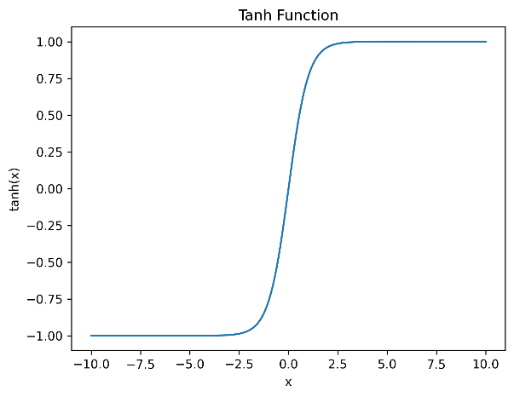
$$tahn^{'}\left(x\right)=1-tahn^{2}(x)$$
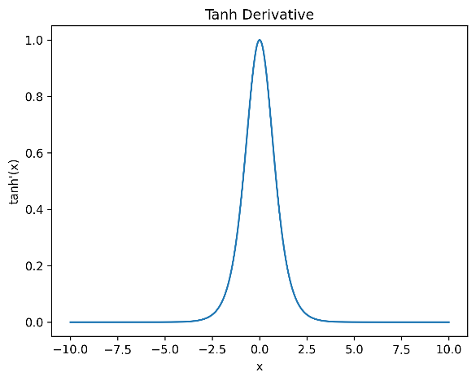
- What is the “vanishing gradient” problem? (respond in no more than 3 sentences) Which activation functions are subject to this issue and why? (respond in no more than 3 sentences).
Vanishing gradients happens when the gradient is multiplied by a flow of small derivatives, converting the gradient into a very trivial number. In neural networks, this gradient is backpropagated to the first layer where it may become so small the previous layers learn very slowly, or not at all.
Which activation functions are subject to this issue and why?
Sigmoid and tanh neurons are particularly vulnerable to this problem because their derivatives are always less than 1 and in the saturating sections, close to 0. Thus, the saturated neurons have near zero gradient, making the vanishing gradient a likely problem with backpropagation.
- Why zero-centered activation functions impact the results of Backprop?
Zero centered activation functions like the tanh activation function can help learning through backpropagation because activations can be both negative and positive for the same layer, which balances the gradient when updating the weights of the neurons. Non zero centered activation functions such as the sigmoid activation function only have positive activations, which can lead to imbalance optimization. Zero centered activations can lead to faster convergence and more stable training.
- Remember the Softmax function $σ\left(\text{z}\right)$ and how it extends sigmoid to multiple dimensions? Let’s compute the derivative of Softmax for each dimension. Prove that:
$$\frac{dσ{\left(z\right)}_{i}}{dz_{j}}=σ{\left(z\right)}_{i}\left(δ_{ij}-σ{\left(z\right)}_{j}\right)$$
- where $δ_{ij}$ is the Kronecker delta function.
- We first need to differentiate using the quotient rule
$$\frac{∂σ_{i}}{∂z_{i} }=\frac{e^{z_{i}}S-e^{z_{i}}*e^{z_{i}}}{S^{2}}=\frac{e^{z_{i}}}{S}*1-\left(\frac{e^{z_{i}}}{S}\right)$$
$$\frac{e^{z_{i}}}{S}=σ_{i}$$
$$\frac{∂σ_{i}}{∂z_{i}}=σ_{i}\left(1-σ_{i}\right)$$

Now since only the denominator depends on z:
$$\frac{∂σ_{i}}{∂z_{j}}=\frac{0*S-e^{z_{i}}*e^{z_{i}}}{S^{2}}=-\frac{e^{z_{i}}}{S}*\frac{e^{z_{i}}}{S}$$
$$\frac{∂σ_{i}}{∂z_{j}}=-σ_{i}*σ_{j}$$
Finally
$$\frac{∂σ{\left(z\right)}_{i}}{∂z_{j}}=σ{\left(z\right)}_{i}\left(δ_{ij}-σ{\left(z\right)}_{j}\right)$$

- Use the above point to prove that the Jacobian of the Softmax function is the following:
$$J_{σ}\left(z\right)=\text{diag}\left(σ\left(z\right)\right)-σ\left(z\right)σ{\left(z\right)}^{⊤}$$
- where $\text{diag}\left(.\right)$ turns a vector into a diagonal matrix. Also, note that $J_{σ}\left(z\right)∈R^{K×K}.$.
given:
$$\frac{∂σ{\left(z\right)}_{i}}{∂z_{j}}=σ{\left(z\right)}_{i}\left(δ_{ij}-σ{\left(z\right)}_{j}\right)$$
We need to separate the terms:
$$σ_{i}\left(δ_{ij}-σ_{j}\right)=σ_{i}δ_{ij}-σ_{i}σ_{j}$$
For diagonal entries:
$$\left(σ_{i}δ_{ij}\right)=diag\left(σ\left(z\right)\right)$$
The outer product is then:
$$\left(σ_{i}σ_{j}\right)=σ\left(z\right)σ{\left(z\right)}^{T}$$
Finally
$$J_{σ}\left(z\right)=diag\left(σ\left(z\right)\right)-σ\left(z\right)σ{\left(z\right)}^{T}$$

Simulating XOR
- Can a single-layer network simulate (represent) an XOR function on $x=\left[x_{1},x_{2}\right]$?
$$y=\text{XOR}\left(x\right)=\left\{\begin{matrix}1, & \text{if }x=\left(0,1\right)\text{ or }x=\left(1,0\right) \\ 0, & \text{if }x=\left(1,1\right)\text{ or }x=\left(0,0\right).\end{matrix}\right.$$
- Explain your reasoning using the following single-layer network definition: $\hat{y}=\text{ReLU}\left(W⋅x+b\right)$
- No, since a single-layer network cannot represent the XOR function.
- A single-layer network with ReLU calculates a linear boundary, in other words we can only properly classify data using a single line. This indicates that the XOR function cannot be separated with a line this is because the two examples are diagonally opposite each other, which indicates that a single hidden layer is needed to express the XOR function, and a network with only a single layer and no hidden layers is not enough.
- Repeat (1) with a two-layer network:
$$\begin{matrix}h=\text{ReLU}\left(W_{1}⋅x+b_{1}\right) \\ \hat{y}=W_{2}⋅h+b_{2}\end{matrix}$$
- Note that this model has an additional layer compared to the earlier question: an input layer $\text{x}∈R^{2}$, a hidden layer $\text{h}$ with ReLU activation functions that are applied component-wise, and a linear output layer, resulting in scalar prediction $\hat{y}$. Provide a set of weights $W_{1}$ and $W_{2}$ and biases ${\text{b}}_{1}$ and $b_{2}$ such that this model can accurately model the XOR problem.
- yes, if we have a two layer network then we can represent XOR.
- if we have
- $W_{1}=\left[\begin{matrix}1 & -1 \\ -1 & 1\end{matrix}\right]$
- $b_{1}=\left[\begin{matrix}0 \\ 0\end{matrix}\right]$
then the ouput layer
- $W_{2}=\left[1, 1\right]$
- $b_{2}=0$
- evaluating all XOR inputs we get:
- (0,0) goes to hidden (0,0) it ouputs 0
- (1,1) goes to hidden (0,0) it ouputs 0
- on the other hand
- (1,0) goes to hidden (1,0) it output 1
- finally
- (0,1) goes to hidden (0, 1) it output 1
- Therefore, the hidden layer separates the diagonal sections using different boundaries. And the output layer adds them which in turn creates a nonlinear boundary. Which is why we need at least one hidden layer.

- Consider the same network as above (with ReLU activations for the hidden layer), with an arbitrary differentiable loss function $l:\left\{0,1\right\}×\left\{0,1\right\}→R$ which takes as input $\hat{y}$ and $y$, our prediction and ground truth labels, respectively. Suppose all weights and biases are initialized to zero. Show that a model trained using standard gradient descent will not learn the XOR function given this initialization.
If all W and B are initialized to zero, the hidden layer will calculate zero for all inputs. The linear combination computes zero for each input and the ReLU activation function returns zero for zero. The output layer will also output zero for all inputs. This in turn will return all four inputs for the XOR function into one constant value.
In gradient descent, since every hidden neuron has the same input which is zero, and produces the same output which is still zero, it also gets the same gradient for every W, preventing the neurons from ever having different values or breaking the balance. In addition, since the derivative of the ReLU is 0 at 0, there is no gradient that would ever reach the first layer, meaning that the first layer's W will not transform.
This network never learns the nonlinear XOR function, because initializing to zero does not break symmetry and does not allow for gradient flow through the hidden nodes.
- Extra Credit: Now let’s consider a more general case than the previous question: we have the same network with an arbitrary hidden layer activation function:
$$\begin{matrix}h=f\left(W_{1}⋅x+b_{1}\right) \\ \hat{y}=W_{2}⋅h+b_{2}\end{matrix}$$
- Show that if the initial weights are any uniform constant, then gradient descent will not learn the XOR function from this initialization.
A computation graph, so elegantly designed
With nodes and edges, so easily combined
It starts with inputs, a simple array
And ends with outputs, in a computationally fair way
Each node performs, an operation with care
And passes its results, to those waiting to share
The edges connect, each node with its peers
And flow of information, they smoothly steer
It’s used to calculate, complex models so grand
And trains neural networks, with ease at hand
Backpropagation, it enables with grace
Making deep learning, a beautiful race
–ChatGPT Feb 3 2023

Neural Nets and Backpropagation
Draw the computation graph for $f\left(x,y,z\right)=lnx+exp\left(y\right)⋅z$. Each node in the graph should correspond to only one simple operation (addition, multiplication, exponentiation, etc.). Then we will follow the forward and backward propagation described in class to estimate the value of $f$ and partial derivatives $\frac{∂f}{∂x},\frac{∂f}{∂y},\frac{∂f}{∂z}$ at $\left[x,y,z\right]=\left[1,3,2\right]$. For each step, show you work.
- Draw the computation graph for $f\left(x,y,z\right)=lnx+exp\left(y\right)⋅z$. The graph should have three input nodes for $x,y,z$ and one output node $f$. Label each intermediate node $h_{i}$.
$$h_{1}$$
X
Ln(x)
$$f$$

+
$$h_{2}$$
Y
exp
$$h_{3}$$
$$h_{2}×z$$
Z

Given:
$$f\left(x,y,z\right)=lnx+exp\left(y\right)⋅z$$
Intermediate or hidden will be
$$hidden_{1}=\ln\left(x\right)$$
$$hidden_{2}=\exp\left(y\right)$$
$$hidden_{3}=hidden_{2}*z$$
$$f=hidden_{1}+hidden_{3}$$
FeedingFoward:
$$hidden_{1}=\ln\left(1\right)=0$$
$$hidden_{2}=e^{3}$$
$$hidden_{3}=e^{3}*2=2e^{3}$$
$$output:$$
$$f=0+2e^{3}=2e^{3}$$
Backpropagation:
$$\frac{∂f}{∂f}=1$$
Derivatives
$$\frac{∂f}{∂hidden_{1}}=1$$
$$\frac{∂f}{∂hidden_{3}}=1$$
$$\frac{∂hidden_{3}}{∂hidden_{2}}=z$$
$$\frac{∂hidden_{3}}{∂z}=hidden_{2}$$
$$\frac{∂hidden_{2}}{∂y}=e^{y}$$
$$\frac{∂hidden_{1}}{∂x}=\frac{1}{x}$$
Applying the Chain Rule:
Gradient x
$$\frac{∂f}{∂x}=\frac{∂f}{∂hidden_{1}}=1*\frac{1}{x}=\frac{1}{x}$$
$$\frac{∂f}{∂x}=1$$
Gradient y
$$\frac{∂f}{∂y}=\frac{∂f}{∂hidden_{3}}=\frac{∂hidden_{3}}{∂hidden_{2}}*\frac{∂hidden_{2}}{∂y}=1*z*e^{y}=ze^{y}$$
So when $y=3, z=2$
$$\frac{∂f}{∂y}=2e^{3}$$
Gradient z
$$\frac{∂f}{∂z}=\frac{∂f}{∂hidden_{3}}*\frac{∂hidden_{3}}{∂z}=1*hidden_{2}=e^{y}$$
So when $y = 3$
$$\frac{∂f}{∂z}=e^{3}$$
Therefore
$$f=2e^{3},\frac{∂f}{∂x}=1,\frac{∂f}{∂y}=2e^{3},\frac{∂f}{∂z}=e^{3}$$

- Run the forward propagation and evaluate $f$ and $h_{i}$ ($i=1,2,…$) at $\left[x,y,z\right]=\left[1,3,2\right]$.
As stated above:
$$hidden_{1}=\ln\left(x\right)$$
$$hidden_{2}=\exp\left(y\right)$$
$$hidden_{3}=hidden_{2}*z$$
$$f=hidden_{1}+hidden_{3}$$
Evaluating
$$hidden_{1}=\ln\left(1\right)=0$$
$$hidden_{2}=e^{3}=20.0855369232$$
$$hidden_{3}=hidden_{2}*z=e^{3}*2=2e^{3}$$
$$2e^{3}= 40.1710738464$$
$$f=hidden_{1}+hidden_{3}=0+2e^{3}=2e^{3}$$
$$f= 40.1710738464$$

Therefore, we get:
$$hidden_{1}=0, hidden_{2}= 20.0855369232, hidden_{3}= 40.1710738464$$
$$f =2e^{3}= 40.1710738464$$

- Run the backward propagation and give partial derivatives for each intermediate operation, i.e., $\frac{∂h_{i}}{∂x}$, $\frac{∂h_{j}}{∂h_{i}}$, and $\frac{∂f}{∂h_{i}}$. Evaluate the partial derivatives at $\left[x,y,z\right]=\left[1,3,2\right]$.
$$hidden_{1}=\ln\left(x\right)$$
$$hidden_{2}=\exp\left(y\right)$$
$$hidden_{3}=hidden_{2}*z$$
$$f=hidden_{1}+hidden_{3}$$
We need to evaluate the partial derivatives with the given values
(x, y, z) = [1,3,2] $x=1, y=3, z=2$
$${hidden}_{1}=\ln\left(x\right):$$
$$\frac{∂hidden_{1}}{∂x}=\frac{1}{x}=\frac{1}{1}=1$$
$$hidden_{2}=\exp\left(y\right):$$
$$\frac{∂hidden_{2}}{∂y}=e^{y}=e^{3}$$
$$hidden_{3}=hidden_{2}*z$$
$$\frac{∂hidden_{3}}{∂hidden_{2}}=z=\frac{∂hidden_{3}}{∂z}=hidden_{2}$$
We know that z=2, and that $hidden_{2}=e^{3}$
$$\frac{∂hidden_{3}}{∂hidden_{2}}=2$$
$$\frac{∂hidden_{3}}{∂z}=e^{3}$$
$$f=hidden_{1}+hidden_{3}:$$
$$\frac{∂f}{∂hidden_{1}}=1$$
$$\frac{∂f}{∂hidden_{3}}=1$$

Gradient of x:
$$\frac{∂f}{∂x}=\frac{∂f}{∂hidden_{1}}*\frac{∂hidden_{1}}{∂x}=1*1=1$$
Gradient of y:
$$\frac{∂f}{∂x}=\frac{∂f}{hidden_{3}}*\frac{∂hidden_{3}}{∂hidden_{2}}*\frac{∂hidden_{2}}{∂y}=1*2*e^{3}=2e^{3}$$
Gradient of z:
$$\frac{∂f}{∂z}=\frac{∂f}{∂hidden_{3}}*\frac{∂hidden_{3}}{∂z}=1*e^{3}=e^{3}$$

Therefore the partial derivatives are:
$$\frac{∂hidden_{1}}{∂x}=1,\frac{∂hidden_{2}}{∂y}=e^{3},\frac{∂hidden_{3}}{∂hidden_{2}}=2,\frac{∂hidden_{3}}{∂z}=e^{3},\frac{∂f}{∂hidden_{1}}=1,\frac{∂f}{∂hidden_{3}}=1$$

- Aggregate the results in (c) and evaluate the partial derivatives $\frac{∂f}{∂x},\frac{∂f}{∂y},\frac{∂f}{∂z}$ with chain rule. Show your work.
$$hidden_{1}=\ln\left(x\right)$$
$$hidden_{2}=\exp\left(y\right)$$
$$hidden_{3}=hidden_{2}*z$$
$$f=hidden_{1}+hidden_{3}$$
We need to evaluate the partial derivatives with the given values
(x, y, z) = [1,3,2] $x=1, y=3, z=2$
Derivative with respect to x
$$\frac{∂f}{∂x}=\frac{∂}{∂hidden_{1}}*\frac{∂hidden_{1}}{∂x}=1*\frac{1}{x}=\frac{1}{1}=1$$
Derivative with respect to y
$$\frac{∂f}{∂y}=\frac{∂f}{∂hidden_{3}}*\frac{∂hidden_{3}}{∂hidden_{2}}*\frac{∂hidden_{2}}{∂y}=1*z*e^{y}$$
$$1*2*e^{3}=2e^{3}$$
Derivative with respect to z
$$\frac{∂f}{∂z}=\frac{∂f}{∂hidden_{3}}*\frac{∂hidden_{3}}{∂z}=1*hidden_{2}=e^{3}$$
Therefore:
$$\frac{∂f}{∂x}=1,\frac{∂f}{∂y}=2e^{3},\frac{∂f}{∂z}=e^{3}$$

Programming
In this programming homework, we will
- implement MLP-based classifiers for the sentiment classification task of homework 1.

Skeleton Code and Structure:
The code base for this homework can be found at this GitHub repo under the hw3 directory. Your task is to fill in the missing parts in the skeleton code, following the requirements, guidance, and tips provided in this pdf and the comments in the corresponding .py files. The code base has the following structure:
- mlp.py reuse the sentiment classifier on movie reviews you implemented in homework 1, with additional requirements to implement MLP-based classifier architectures and forward pass .
- main.py provides the entry point to run your implementations mlp.py
- hw3.md provides instructions on how to setup the environment and run each part of the homework in main.py
TODOs — Your tasks include 1) generate plots and/or write short answers based on the results of running the code; 2) fill in the blanks in the skeleton to complete the code. We will explicitly mark these plotting, written answer, and filling-in-the-blank tasks as TODOs in the following descriptions, as well as a # TODO at the corresponding blank in the code.
TODOs (Copy from your HW1). We are reusing most of the model.py from homework 1 as the starting point for the mlp.py - you will see in the skeleton that they look very similar. Moreover, in order to make the skeleton complete, for all the # TODO (Copy from your HW1), please fill in the blank below them by copying and pasting the corresponding implementations you wrote for homework 1 (i.e. the corresponding # TODO in homework 1.)

Submission:
Your submission should contain two parts: 1) plots and short answers under the corresponding questions below; and 2) your completion of the skeleton code base, in a .zip file

MLP-based Sentiment Classifier
In both homework 1 & 2, our implementation of the SentimentClassifer is essentially a single-layer feedforward neural network that maps input features directly to 2-dimensional output logits. In this part of the programming homework, we will expand the architecture of our classifier to multi-layer perceptron (MLP).

Reuse Your HW1 Implementation
TODOs (Copy from your HW1): for all the # TODO (Copy from your HW1) in mlp.py, please fill in the blank below them by copying and pasting the corresponding implementations you wrote for homework 1 (i.e. the corresponding # TODO in the model.py in homework 1).

Build MLPs
Remember from the lecture that MLP is a multi-layer feedforward network with perceptrons as its nodes. A perceptron consists of non-linear activation of the affine (linear) transformation of inputs.
TODOs: Complete the __init__ and forward function of the SentimentClassifier class in mlp.py to build MLP classifiers that supports custom specification of architecture (i.e. number and dimension of hidden layers)
Hint: check the comments in the code for specific requirements about input, output, and implementation. Also, check out the document of nn.ModuleList about how to define and implement forward pass of MLPs as a stack of layers.

Train and Evaluate MLPs
We provide in main.py several MLP configurations and corresponding recipes for training them.
TODOs Once you finished 6.1.2, you can run load_data_mlp and explore_mlp_structures to train and evaluate these MLPs and paste two sets of plots here:
- 4 plots of train & dev loss for each MLP configuration
None
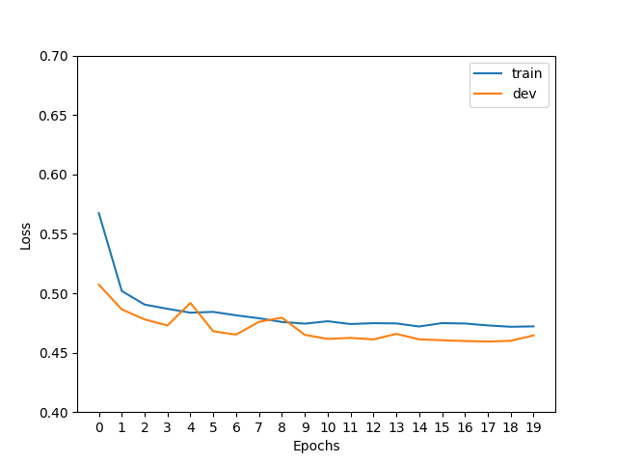
512
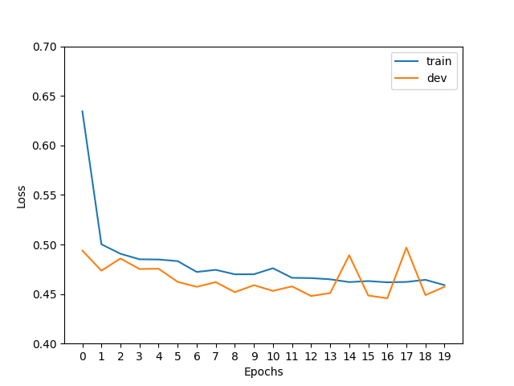
512 → 512
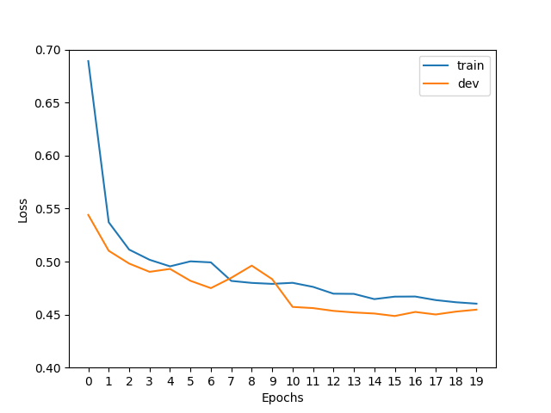
512 → 512 → 512
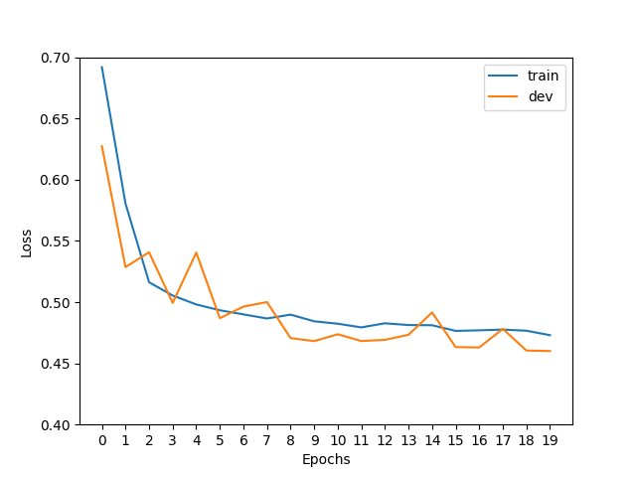
- 2 plots of dev losses and accuracies across MLP configurations
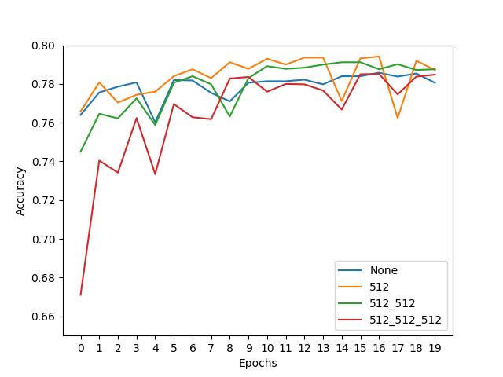
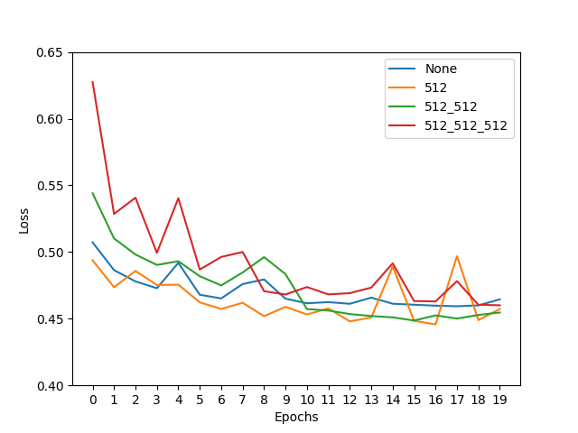
and describe in 2-3 sentences your findings.
Hint: what are the trends of train & dev loss and are they consistent across different configurations? Are deeper models always better? Why?
The training loss of train and dev data decreased rapidly in the first several epochs to about between .50 to .45 loss for the training set for the dev set we can see some fluctuation but eventually it converges with the training set, then plateaued for all runs. We can also note that the loss in the first none hidden layers start at about just a little above 0.55. On the other hand Deeper models seem to start minimizing loss above 60 and increasing as more hidden layers are added, but ultimately, they all converge at about between .50 and .45. This shows that deeper models do not necessarily generalize better, possibly because a limited dataset may not support the added complexity of deeper models.
Now looking at them together in the last two graphs. We can see 1 hidden layer had the highest fluctuation while the more hidden layer that are added fluctuation still happens but at a lower height than with one single layer meanwhile the no hidden layers fluctuates at the beginning but as it converges no fluctuations are visible this tells us the complexity of the hidden layer might affect how the model learns the data and for this specific data set it hurts having multiple layer than benefits the model.

Embrace Non-linearity: The Activation Functions
Remember we have learned why adding non-linearity is useful in neural nets and gotten familiar with several non-linear activation functions both in the class and 3. Now it is time to try them out in our MLPs!
Note: for the following TODO and the TODO in 6.1.5, we fix the MLP structure to be with a single 512-dimension hidden layer, as specified in the code. You only need to run experiments on this architecture.
TODOs: Read and complete the missing lines of the two following functions:
- __init__ function of the SentimentClassifier class: define different activation functions given the input activation type.
Hint: we have provided you with a demonstration of defining the Sigmoid activation, you can search for the other nn.<activation> in PyTorch documentation.
- explore_mlp_activations in main.py: iterate over the activation options, define the corresponding training configurations, train and evaluate the model, and visualize the results. Note: you only need to generate the plots of dev loss and dev acc across different configurations, by calling visualize_configs, you do not need to plot the train-dev loss curves for each configuration (i.e. no need to call visualize_epochs). We provide you with a few choices of common activation functions, but feel free to try out the others.
Hint: You can refer to explore_mlp_structure as a demonstration of how to define training configurations with fixed hyper-parameters & iterate over hyper-parameters/design choices of interests (e.g. hidden dimensions, choice of activation), and plot the evaluation results across configurations.
Once you complete the above functions, run explore_mlp_activations and paste the two generated plots here. Describe in 2-3 sentences your findings.

Sigmoid
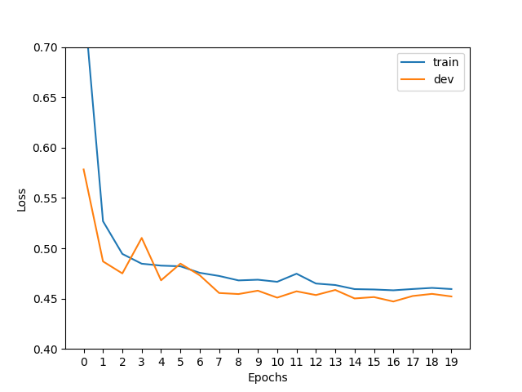
Tahn
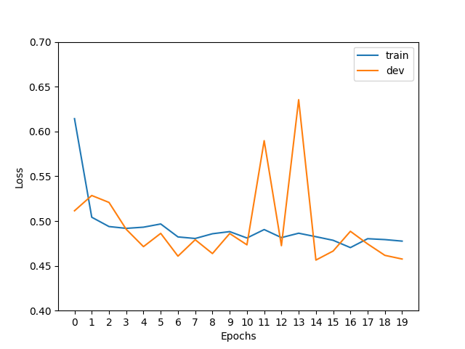
ReLU
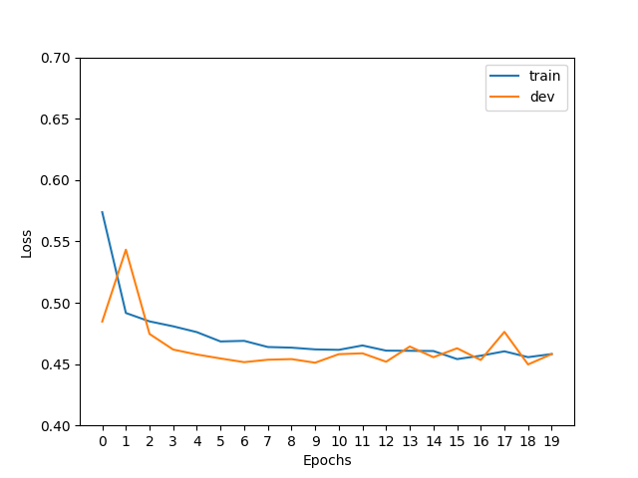
GeLU
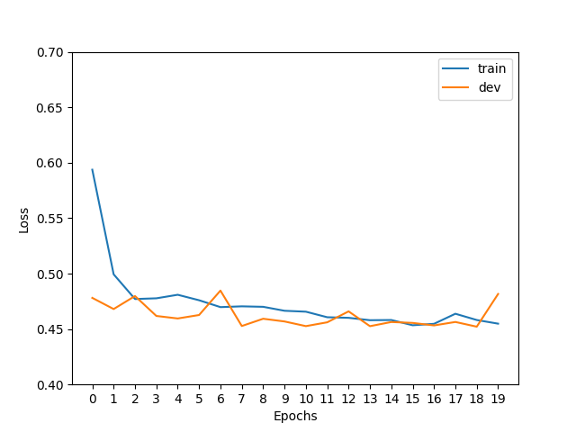
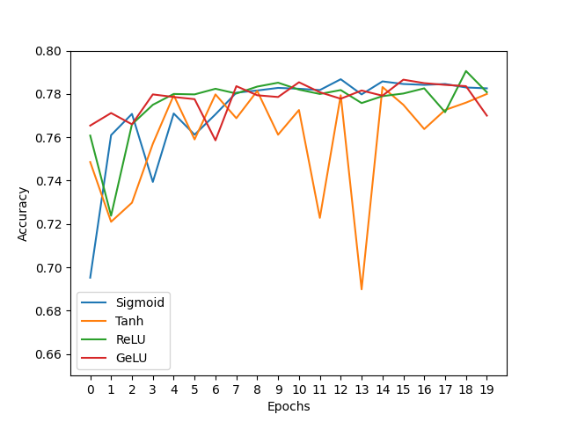

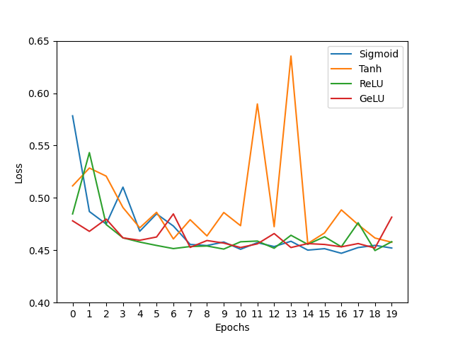
As we can see per the activation function Sigmoid and Tahn have the most fluctuations. Tahn having the biggest spikes compare to the other activation functions as we can see from the last graph where the spikes of Tahn reach pass 0.60 loss and .70 accuracy. On the other hand GeLU and ReLU achieve a smoother and consistent decrease in dev loss. Even though there are some spikes between them they perform better than Sigmoid and Tahn this shows the importance of the choice at the time of choosing an activation function so that you can have a smooth convergence as oppose to noise and spike driven activation.

Hyper-parameter Tuning: Learning Rate
The training process mostly involves learning model parameters, which are automatically performed by gradient-based methods. However, certain parameters are “unlearnable" through gradient optimization while playing a crucial role in affecting model performance, for example, learning rate and batch size. We typically refer to these parameters as Hyper-parameters.
We will now take the first step to tune these hyper-parameters by exploring the choices of one of the most important one - learning rate, on our MLP. (There are lots of tutorials on how to tune the learning rate manually or automatically in practice, for example this note can serve as a starting point.)
TODOs: Read and complete the missing lines in explore_mlp_learning_rates in main.py to iterate over different learning rate values, define the training configurations, train and evaluate the model, and visualize the results. Note: same as above, you only need to generate the plots of dev loss and dev acc across different configurations, by calling visualize_configs, you do not need to plot the train-dev loss curves for each configuration (i.e. no need to call visualize_epochs). We provide you with the default learning rate we set to start with, and we encourage you to add more learning rate values to explore and include in your final plots curves of at least 4 different representative learning rates.
Hint: again, you can checkout explore_mlp_structure as a demonstration for how to perform hyper-parameter search.
Once you complete the above functions, run explore_mlp_learning_rates and paste the two generated plots here. Describe in 2-3 sentences your findings.
Accuracy
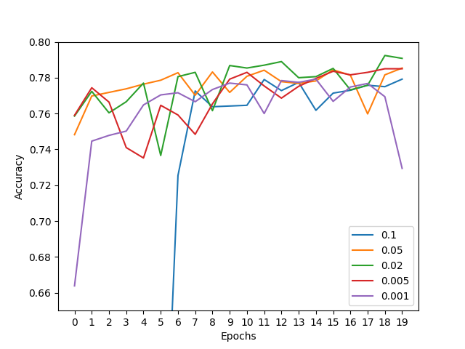
Loss
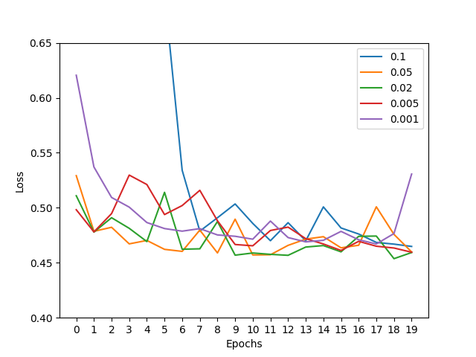
A very large learning rate like 0.1 will show big fluctuations as we can see from the blue line. The fluctuations start early as opposed to the other learning rates they start decreasing much earlier in the epoch because the algorithm is learning at a more stable slow rate. So, 0.1 leads to unstable training while 0.001 converges with minimal fluctuations. Usually, middle numbers like 0.02 and 0.05 create the best balance, but as we can see the learning rate that performs the best converging at a lower and still decreasing rate is 0.005. This one provides the best balance and stability for the model with a consistent dev loss at epoch 19.

https://en.wikipedia.org/wiki/Kronecker_delta

